**Name: Syazmin Hazeeq Bin Syafiq**

**Class: 1K6**

**Topic: Computer Science Task 3 Submission**

1. **Creating Table**

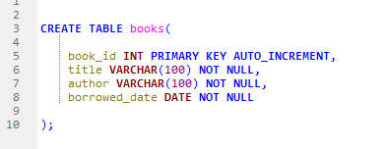

**Outcome:**



1. **Data Entry**

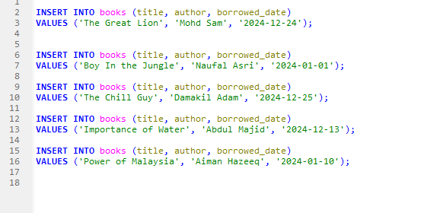

**Outcome:**

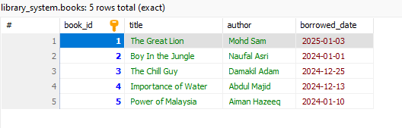

1. **List all books**

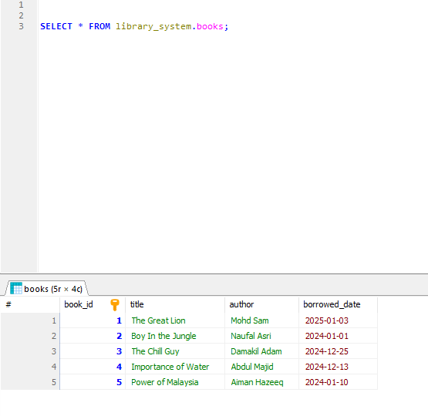

1. **Find books by author**

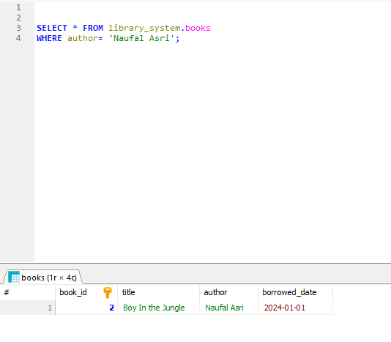

1. **Find books borrowed on a specific date**

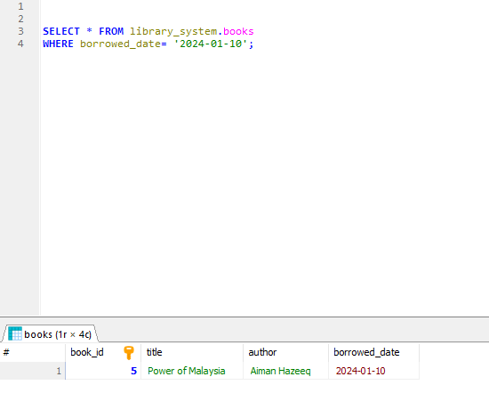

1. **Find books borrowed after a certain date**

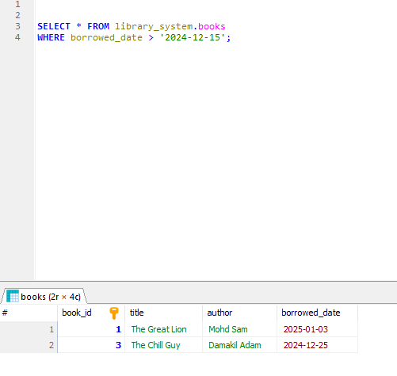

1. **Update borrowed_date**

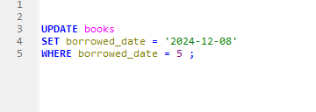

**Outcome:**

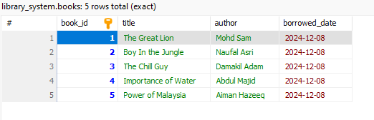

1. **Delete a book**

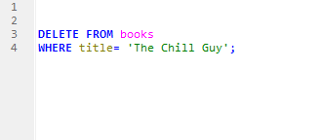

**Outcome:**

